- It's going to extend our previous example of the reflection agent, but it's going to incorporate tools, for example, a search tool which is going to search online for real time data to enrich our answer.
- We're going to review some advanced prompt engineering techniques in order for our reflexion agent to be able to digest the feedback correctly and to really address and improve through the iterations, because to create a critique, it's not that hard, but to really leverage the LLM to incorporate that critique and to improve over time is something which is challenging. And for that, we're going to show you some very cool tricks that will help us do so.
- Now, where does this architecture come from?
- It comes from a paper which is called Reflexion, which is a joint paper from northeastern, MIT and Princeton(https://arxiv.org/pdf/2303.11366).
- So the idea for this actually came from a langchain blog(https://www.langchain.com/blog/reflection-agents) that their team created, covering reflection agents and specifically covering the reflexion paper implementing everything with LangGraph.
- Now, I have to say that the Langchain team, they did an amazing work. However, their implementation was a bit hard to understand, so it really took me a long time to understand what was going on.

- So, what I did is take it and refactor it a bit in order to make it something which is much easier to explain and easier to digest, because the implementation was quite hard to understand.
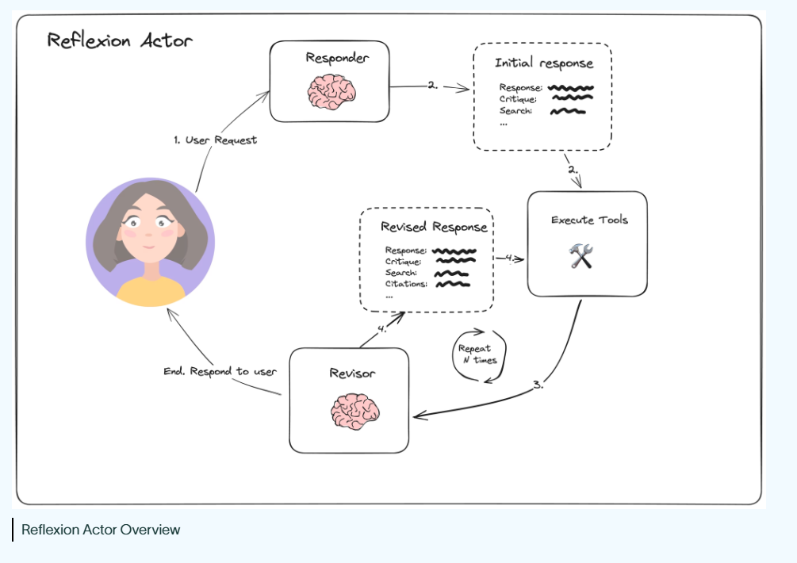
- The goal of the reflexion agent is to give us a very detailed article about a topic that we will give, and we want the article to dynamically fetch relevant information from the web, and we want to have citations for the reference data. And of course we want to incorporate a quality right critique loop. We basically want to get a very high-quality answer.

- Example topic: AI-powered SOC (Security Operations Center) / hyperautomation startups
- These startups focus on:
  - Automating Tier 1 security tickets
  - Using AI agents to resolve basic incidents
  - Reducing workload for human SOC analysts
- Key idea:
  - Many security tickets require low reasoning
  - AI can:
    - Triage incidents
    - Use external tools
    - Automatically resolve common issues

Reflexion Agent Architecture
- The architecture is similar to a reflection agent we discussed previously
- 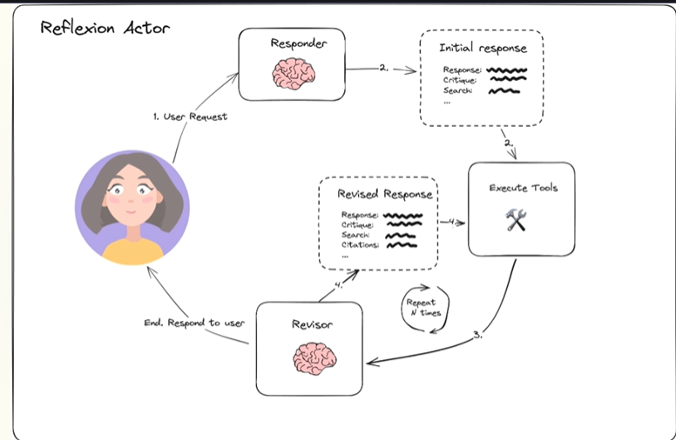
- Flow starts with a Responder Node
  - Generates:
    - Initial response
    - Self-critique
    - Search queries
- In Search Query Generation
  - Agent creates queries to:
    - Improve answer quality
    - Ground responses in real-world/current data
- Execute Tools Node
  - Takes search queries
  - Uses a search engine (e.g., Tavily)
  - Retrieves real-time external data
- Revisor Node
  - Inputs:
    - Initial response
    - Critique
    - Search results
  - Outputs:
    - Improved/revised response
    - New critique
    - New search queries
    - Citations from previous search

Iterative Loop
- Process repeats:
  - Generate → Critique → Search
  - Retrieve data
  - Revise response
- Continues until:
  - A stopping condition is reached

Key Enhancements Over Basic Reflection Agent
- Addition of:
  - Search engine integration
  - Real-time data grounding
  - Citations
